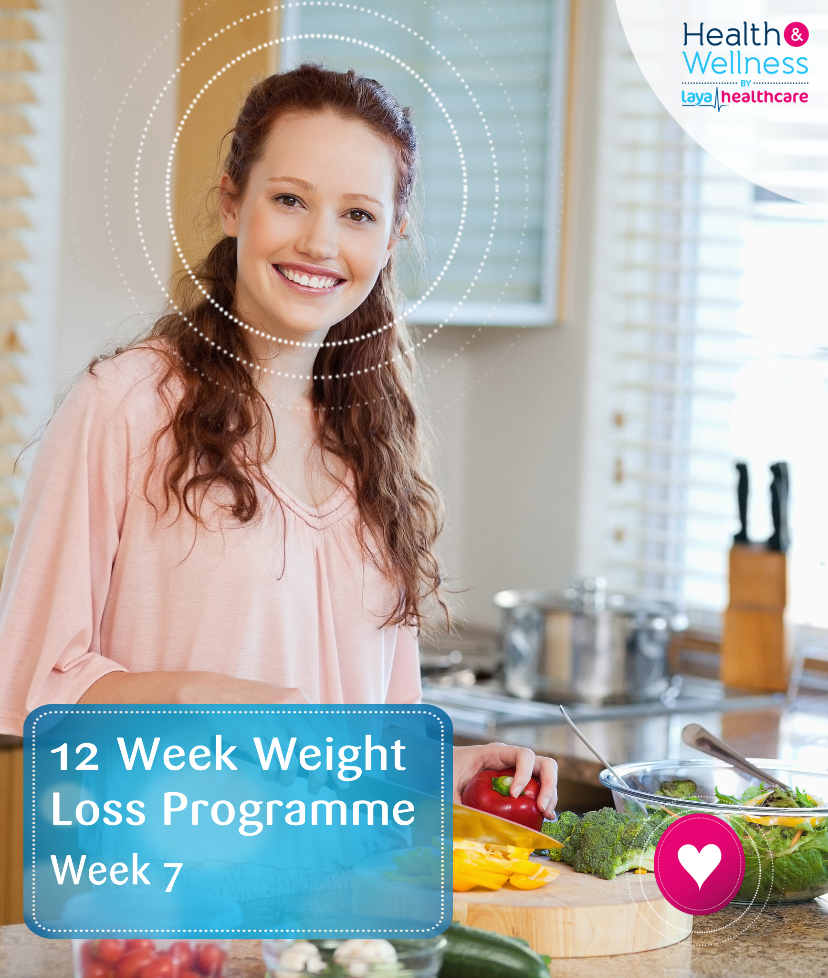

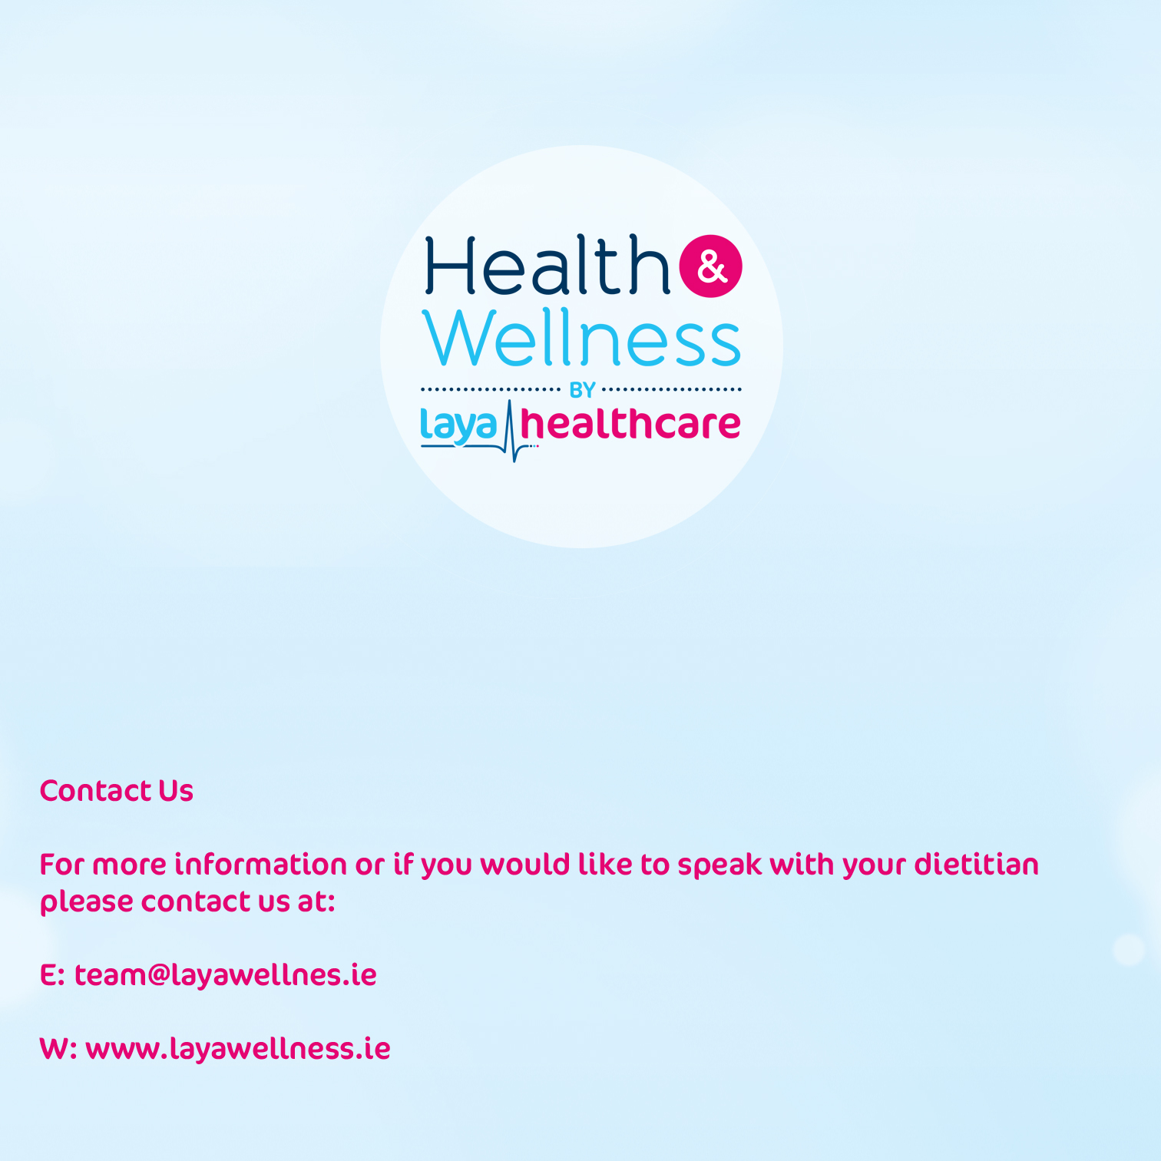

Eating Out Exercise
What are your favourite takeaways and places to eat out?

How can you improve your choices?

Collect some menus from restaurants or take-away venues you use. Try and pick out the healthier options and be prepared to discuss them at the next appointment.


Table of Contents



Eating Out…………………………………………………………2

“On the Go” Food…………………………………..3

Take Away Food…………………………………...5

Restaurant Food……………………………………7

Eating Out Exercise……………………………….14



Eating Out

‘Eating out’ includes eating at the cafeteria at work or school, food from the takeaway, or food at a restaurant or café. If you eat out regularly (once a week or more) the choices you make are important and will affect your ability to lose weight. If you rarely eat out (once a month or less) ENJOY your favourite foods.
Here are some tips if you are going out to eat
- Sometimes we eat out later than we would normally eat at home. Having something small before going out e.g. a small bowl of cereal or diet yoghurt may help so you won’t be ravenously hungry when you arrive at the restaurant.
- Enjoy 2 favourite courses rather than 3; choose either a starter and a main course, or a main course and dessert.
- Choosing broth type soups rather than ‘cream of’ for starters will cut down on the calories, as will having fruit/sorbets as a dessert rather than the richer cakes and puddings.
- Choosing a starter portion as a main course also means you can enjoy more courses without increasing your calories too much.
- Dipping into the bread-basket before your meal can be a mistake if you dip into the butter as well. Have bread if you are not having a starter and try it without butter or oil.
- Being careful with buffet and BBQ meals means you can enjoy tempting bits in moderation.
- Survey the choice available first.
- Choose smaller portions of favourite (but maybe higher fat) foods, taking care to fill up on the healthy options available.
- Stand well clear of the table afterwards.


Be Assertive: Questions to ask the waiter/waitress

What does the meal come with?
- Ask for jacket potato or rice instead of chips.
- If there are 2 types of potato offered ask for salad instead of 1 of these.

How is it cooked?
- Ask for the meat/chicken/fish to be grilled/baked or steamed instead of fried.

Does the meal come with a sauce/dressing?
- Ask for tomato based sauces or sauces without cream or butter.
- Ask for your dressing on the side so you can control how much you have.

Does the meal have a lot of cheese?
- Lasagnes, pizzas, moussakas and other meals can have a lot of cheese, if freshly made ask for less cheese.

How are the vegetables served?
- Ask for extra vegetables served without butter/ cream/olive oil.

Is it possible to have something else rather than chips or roast potatoes?
- Ask for an extra portion of vegetables or salad if boiled potatoes aren’t available.


- Stifado (beef and tomato casserole), and lamb or pork souvlaki (grilled kebabs) are better choices than moussaka (beef or vegetarian) which can be very oily with lots of cheese.
- Choose chicken with lemon and garlic, fish, chicken or vegetable tagine with tomatoes, cous cous or bulgur wheat served with lamb, bisara (lentil purée with cumin, chilli and olives), grilled or baked fish (psarai plaki).
- Ask for calamari to be grilled rather than fried.
- Avoid meatballs (keftedakia), moussaka, and pastutsui (lamb and pasta casserole) and spicy sausages.
- Try fruit salad, date and banana dessert, or orange slices with cinnamon rather than baklava and creamy cakes for dessert.

The JAPANESE Meal
- Japanese food tends to be low in fat and a very good choice for those trying to eat healthier.
- Choose sushi, sashimi, sukiya, and teryaki dishes over anything fried such as tempura.
- Try hot soups, steamed dumplings or barbequed skewers of chicken for starters.
- Mains such as sliced pork in ginger and soy, or tuna/beef/chicken teriyaki are better choices over anything fried.



‘ON THE GO’ FOOD

Sandwiches
Many of us have sandwiches for lunch. Making your own at home is always the best option as this way you can choose how much spread and filling to use. Buying sandwiches in supermarkets and snack bars is a convenient alternative however so if you don’t always have time follow these tips to get the healthiest option:
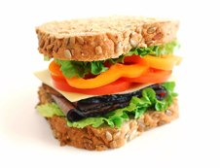
- Choose granary or wholemeal breads and rolls.
- Ask for sandwiches to be made without spread.
- If having a dressing choose low fat options of mayonnaise and salad cream if available, or ask for tomato, BBQ or chilli sauce instead.
- Chose low fat fillings such as chicken, ham, egg, tuna, or cottage cheese and request extra salad.
- Try smoked salmon with salad rather than cream cheese.
- Try meats with horseradish or mustard rather than mayonnaise or salad cream.



- When choosing ready-made sandwiches look for packs with less than 350 Kcal or 15g fat for the whole sandwich.
- Bump up your fruit intake by following your sandwich with a piece of fruit or a fruit salad rather than having it with a packet of crisps, which will only bump up your fat intake.

Jacket Potatoes
- Choose moist fillings and ask for your potato without butter or margarine.
- Pick low fat fillings such as baked beans, cottage cheese chilli con carne, vegetable chilli or ratatouille, chicken salad, and vegetable curry.
- Have lots of salad on the side to help fill you up. Ask for oil and vinegar on the side rather than having a creamy dressing.



The FRENCH Meal

- Choose consommé served without butter as a starter instead of French onion soup.
- Choose grilled fish, meat (e.g. steak au poivre), boeuf bourguignonne, poultry dishes without creamy sauces, ratatouille, salads (e.g. niçoise) and bouillabaisse (fish stew) as main courses.
- Limit creamy or butter sauces (e.g. à la Normandie, bernaise) buttered vegetables, pastry dishes and profiteroles.

The GREEK or MIDDLE EASTERN Meal

- Choose shish kebab over doner and kofta kebabs that are much higher in fat.
- Try grilled haloumi with salad, Greek salad, tomato and cucumber salad, aubergine salad, mechouia (grilled vegetable salad), dolma (stuffed vine leaves) with meat or vegetables, pitta bread or bread with tzatziki or tabouleh salad.
- Limit high fat dishes such as hummus, falafel and taramasalata.
- Fava bean and chick pea soup are low calorie/fat dishes.
- As a main course try a mixed grill served with a variety of salads.



The MEXICAN meal
- Try to avoid high fat starters such as nachos with sour cream, deep fried potato skins and stuffed jalapeno peppers.
- Choose instead corn tortillas with salsa and try and share with friends.
- Try burritos, enchiladas, fajitas or chilli-con-carne instead of chimichangas and quesadillas as main courses and try to limit your intake of sour cream and refried beans which are sometimes served as accompaniments.
- Other good choices are Taco salad, or tacos filled with vegetarian, chicken or beef filling with salad on the side.

The SPANISH or PORTUGUESE Meal
- Choose paella, grilled fish and shellfish dishes, salads with oil and vinegar (ask to add this yourself), and gazpacho.
- Try to limit buttery and oily sauces, fried fish pies, and fried chicken.
- Portuguese cakes for pudding can be replaced with fruit salad or sorbet.



TAKE AWAY FOOD

Fish & Chip Shops/Burger Bars
Here are some ideas to reduce the fat content of these options for take away food
- Ask for grilled instead of battered fish.
- Leave some or most of the batter, but eat all of the fish inside.
- Share a portion of chips with somebody else or have less chips.
- Choose plain burgers with salad instead of cheese or fried egg burgers and chips.
- Choose grilled meat/chicken/fish burgers where possible.
- Ask for no cheese or mayonnaise on your burger, (contains much of the fat), have tomato sauce and mustard instead.
- Choose diet drinks instead of regular, and avoid high fat milkshakes.
- Avoid ribs and skip fried desserts such as doughnuts.
- Frozen yoghurt, sorbets or fruit salads are tasty alternatives to apple pie and ice cream, or cheesecake.



Caribbean choice
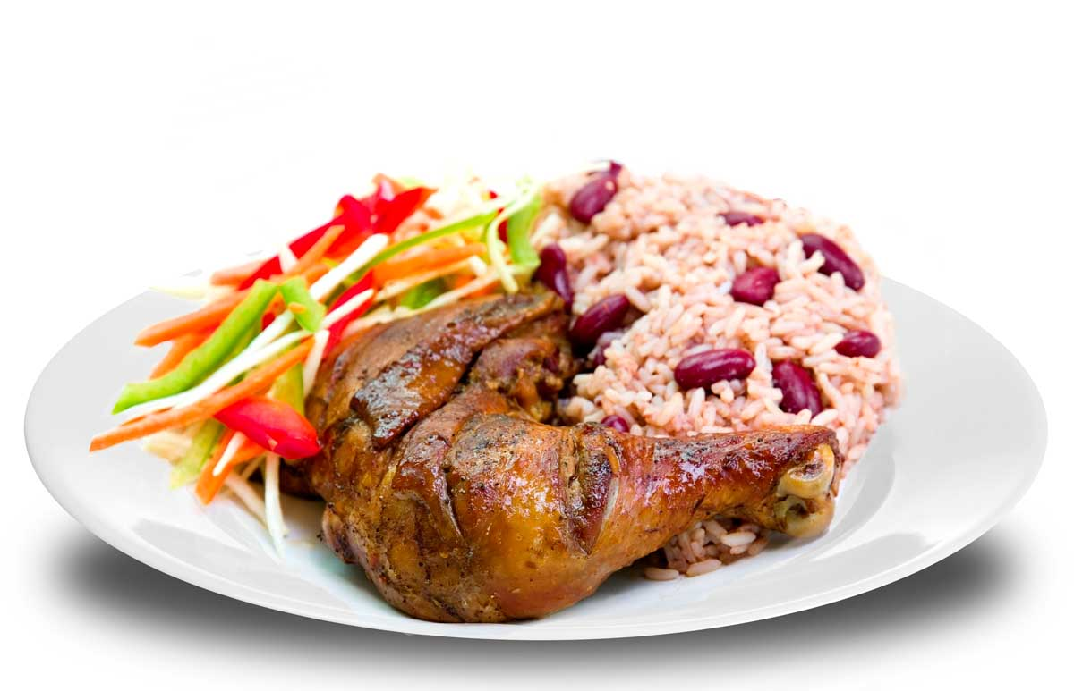
- A healthy choice is chicken, beef, fish or goat curry.
- Choose rice and peas, or salt fish and ackee.
- Ask for grilled jerk chicken or pork and try to avoid fried chicken and fried fish.
- Choose foods cooked without coconut or condensed milk.
- Grilled, baked or boiled yam, sweet potato, bread fruit, plantain, roti and green banana are tasty accompaniments to fish and curried meats.

RESTAURANT FOOD

We are eating more and more different kinds of food every year and sometimes it is difficult to know whether we are making the healthiest choice when eating out. Here are some tips to help you along the way:


The THAI Meal
- Sour soups made with broth and vegetables, prawns, chicken and noodles are healthy starters.
- Limit intake of prawn crackers.
- Not all Thai dishes are cooked with coconut milk though red and green curries generally are – leaving some of the juice behind will cut down on the overall fat content of your meal.
- Many fish dishes are poached/steamed or made with low calorie sauces such as tamarind.
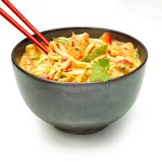
- Try steamed noodles and rice instead of fried.
- Jasmine rice is a delicious alternative to coconut or fried rice.
- Try meat or vegetable dishes with chilli, lemon grass or soy rather than peanut or coconut cream based dishes.
- Fish cakes, spring rolls ad curry puffs will all be high in fat and are best limited.
- Avoid fried dishes for puddings such as banana fritters, opt instead for lychees, sorbet or a scoop of ice-cream.



The INDIAN Meal

- Choose dhal, tandoori or tikka dishes, or dishes based on yoghurt or tomato instead of butter, cream or nut sauces.
- Choose steamed/boiled rice or chapatti instead of biriyani, fried or pilau rice.
- Limit masalas, kormas, dansak, and poppadoms as well as fried foods such as samosas, bhajias, puri, paratha and pakora.
- Breads such as plain naan, roti and chapatti are good choices if they are cooked without butter or ghee.
- Try having bread or rice but not both.
- Lentil soup is a good choice for a starter.
- Pickles, raita and onion salad are all low in fat healthy accompaniments to your meal.


The ITALIAN Meal
- Choose plain bread instead of garlic bread or have a side salad instead as a starter.
- Choose thin crust pizzas, not cheese filled or deep crust.
- Try ham, tuna, prawns and any vegetables instead of pepperoni or sausage for pizza toppings, and ask for less cheese.
- Choose tomato or vegetable-based sauces for pasta such as Neapolitan or arrabiata; and try to avoid sauces with cream, cheese or pesto (e.g. carbonara, alfredo).
- Limit creamy cakes/puddings e.g. tiramisu or zabaglione, have a sorbet or non-dairy gelati instead.

The CHINESE Meal
- Choose clear soups with wonton, noodles and vegetables, e.g. long soup, or hot and sour soup.
- Choose steamed or boiled rice or noodles instead of fried.
- Try stir-fried dishes such as chow mein, chop suey or foo yung.
- Choose meat or vegetables based dishes made with sauces such as black or yellow bean, chilli, oyster and soy sauce.

- Choose steamed rather than fried spring rolls & dim sums.
- Try to avoid anything deep fried or in batter e.g. sweet and sour chicken, pork or crispy beef/duck and pork balls.

